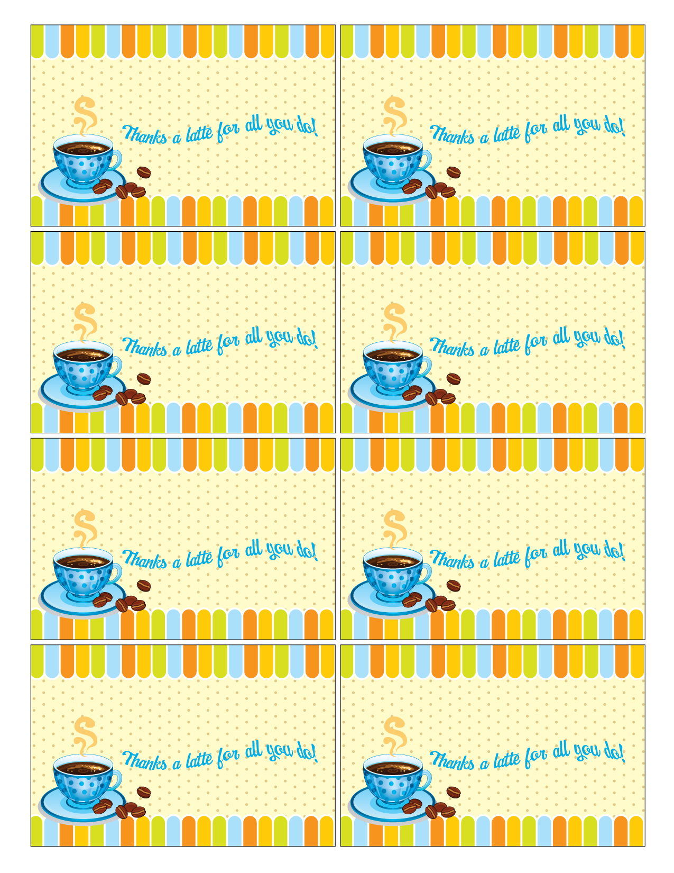
Teacher’s Name Here
Your Name
Here

Teacher’s Name Here
Your Name
Here

Teacher’s Name Here
Your Name
Here

Teacher’s Name Here
Your Name
Here

Teacher’s Name Here
Your Name
Here

Teacher’s Name Here
Your Name
Here

Teacher’s Name Here
Your Name
Here

Teacher’s Name Here
Your Name
Here

