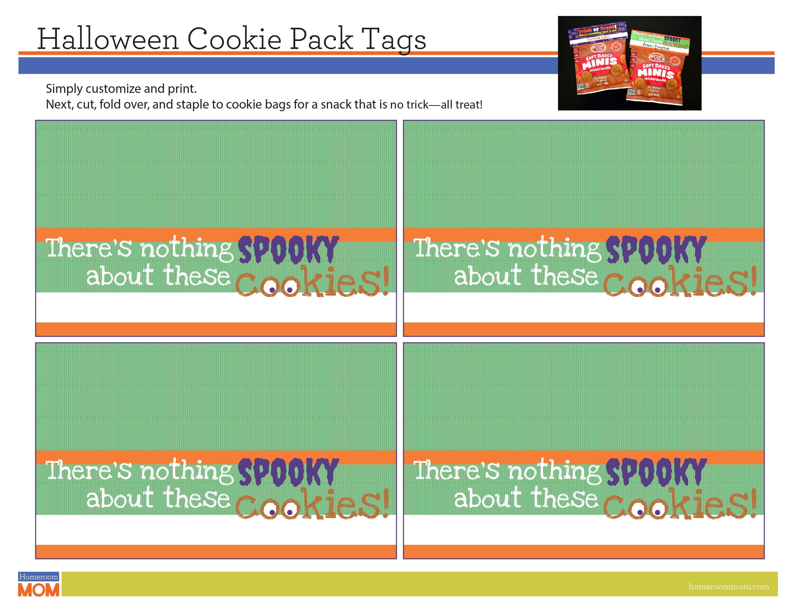
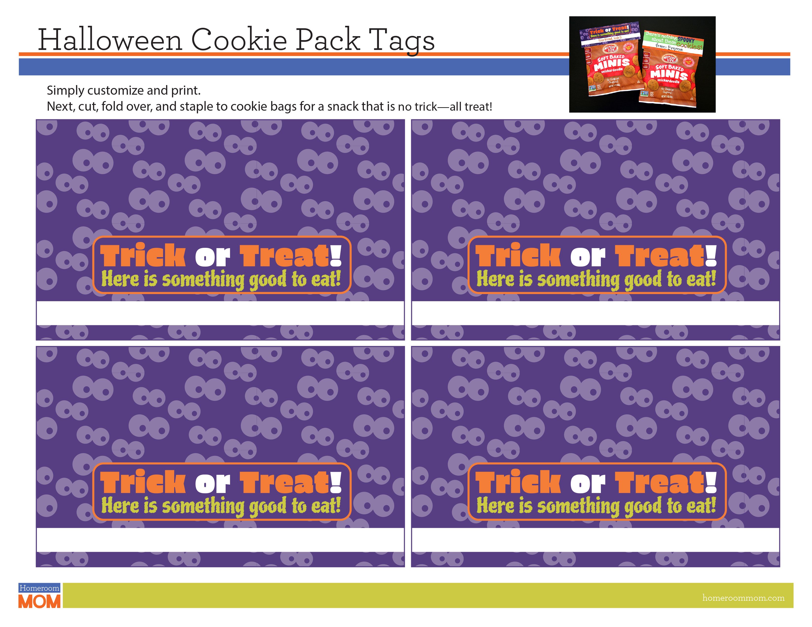
from: Emma
from: Emma
from: Emma
Your friend, Josh D.
Your friend, Josh D.
Your friend, Josh D.
Your friend, Josh D.
from: Emma

