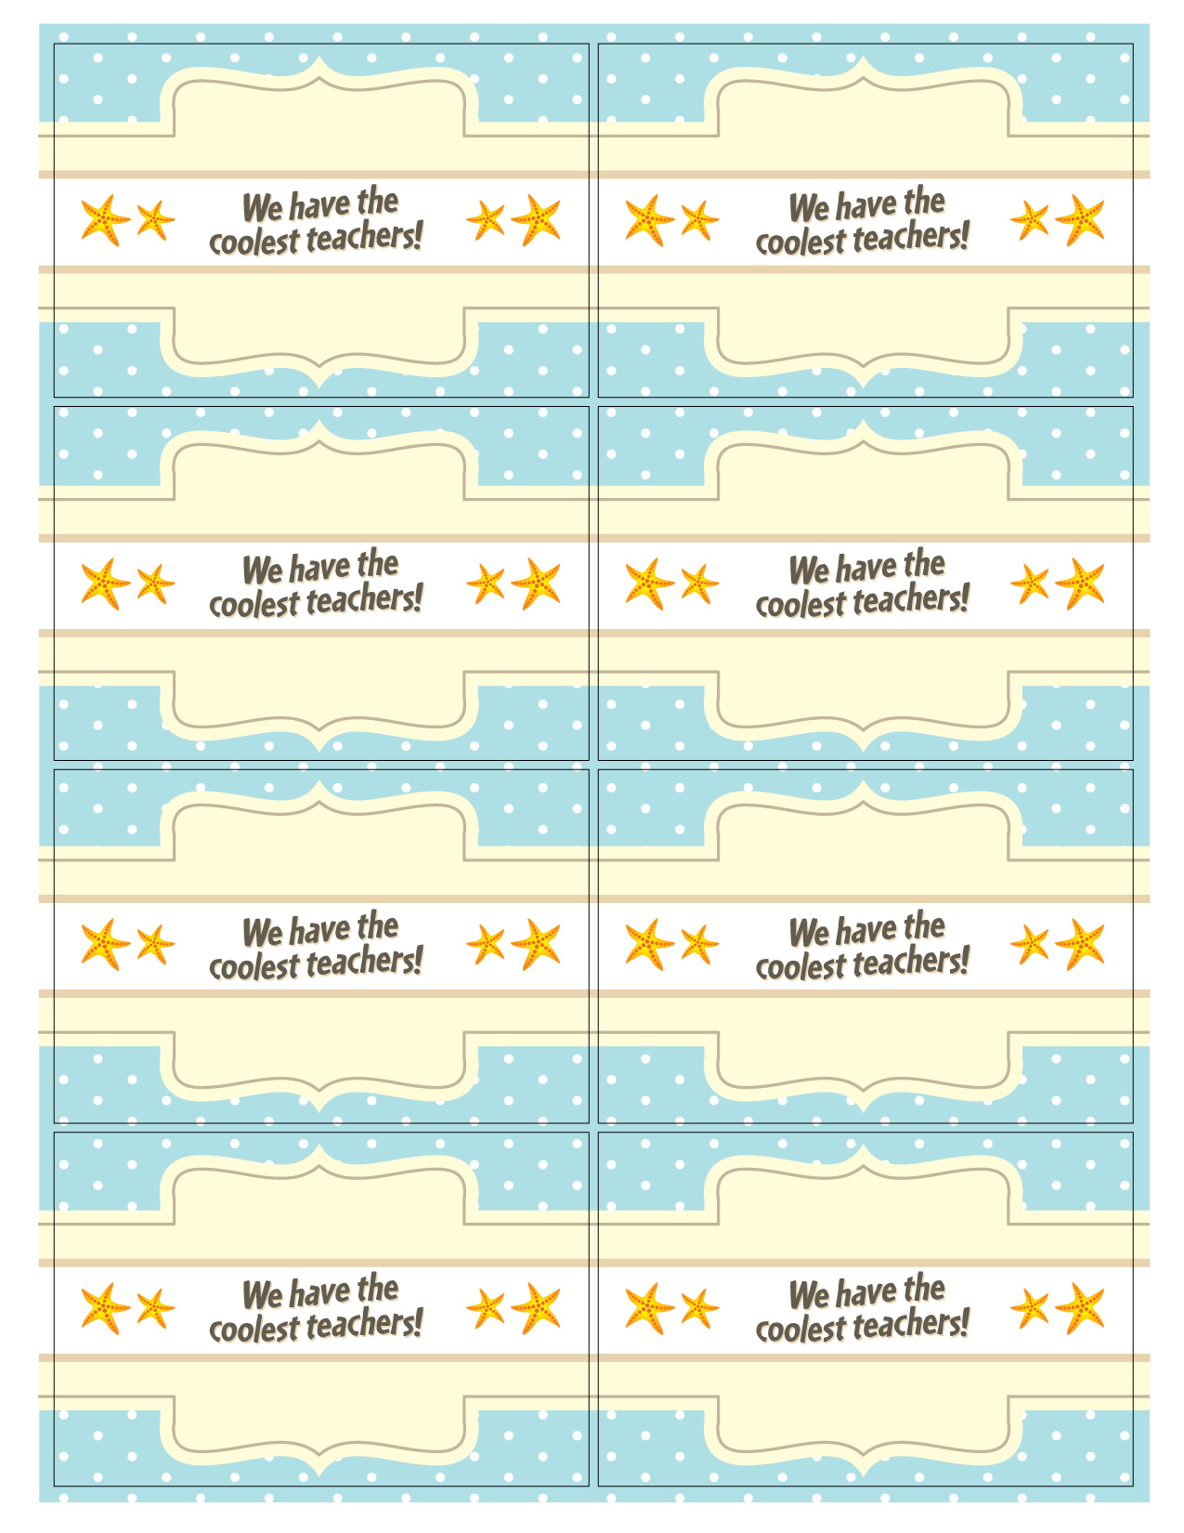
Teacher’s
Name
Your Name

Teacher’s
Name

Your Name

Teacher’s
Name
Your Name

Teacher’s
Name
Your Name

Teacher’s
Name
Your Name

Teacher’s
Name
Your Name

Teacher’s
Name
Your Name

Teacher’s
Name
Your Name

